**Assignment 3 Template**

**LAST NAME: Lawson**

**FIRST NAME: John**

**USERID: jd2lawso**

**UWaterloo ID: 20466075**

**Problem 1: Fill in the information below based on your data which were generated using your ID number as the seed for the random number generator.**

**n = 30 theta = 0.319**

**The first 10 approximate 95% confidence intervals are:**

**[,1] [,2]**

**[1,] 0.10842147 0.4249119**

**[2,] 0.13601463 0.4639854**

**[3,] 0.10842147 0.4249119**

**[4,] 0.19422297 0.5391104**

**[5,] 0.05686184 0.3431382**

**[6,] 0.13601463 0.4639854**

**[7,] 0.05686184 0.3431382**

**[8,] 0.10842147 0.4249119**

**[9,] 0.08198169 0.3846850**

**[10,] 0.19422297 0.5391104**

**Do all 10 intervals contain only values between 0 and 1? YES/NO**

**Yes**

**Depending on the value of theta is it possible that some intervals will not contain only values between 0 and 1? Why or why not?**

**Yes, because the 95% confidence interval can have 5% of its sampled intervals which do not contain the parameter.**

**The proportion of approximate 95% confidence intervals which contain the true value of theta = 0.915**

**How close is this proportion to 0.95? What are the reasons for this?**

This value differs from 0.95 by about 3-4 %. This is due to the value of n=30 being relatively small; if the script is run with n=100, n=1000, n=10000... and so on, the proportion of intervals containing true theta, becomes closer and closer to 0.95.

**The first ten 15% likelihood intervals (approximate 95% likelihood intervals) are:**

**[,1] [,2]**

**[1,] 0.13255152 0.4386053**

**[2,] 0.15784848 0.4745779**

**[3,] 0.13255152 0.4386053**

**[4,] 0.21120361 0.5437472**

**[5,] 0.08532625 0.3632465**

**[6,] 0.15784848 0.4745779**

**[7,] 0.08532625 0.3632465**

**[8,] 0.13255152 0.4386053**

**[9,] 0.10831635 0.4015641**

**[10,] 0.21120361 0.5437472**

**Do all 10 likelihood intervals contain only values between 0 and 1? YES/NO  
  
Yes**

**Depending on the value of theta is it possible that some likelihood intervals will not contain only values between 0 and 1? Why or why not?**

**Yes, because the 15% likelihood interval of the sample chosen may be offset by the sample chosen.**

**The proportion of 15% likelihood intervals which contain the true value of theta = 0.9506**

**How close is this proportion to 0.95? What are the reasons for this?  
  
This differs by less than 0.06 %, since likelihood intervals are a better method for estimating likely bounds for parameter theta than confidence intervals when the sample size is small.**

**Insert the plot of the sampling distribution of the likelihood ratio statistic for n=30 here.**

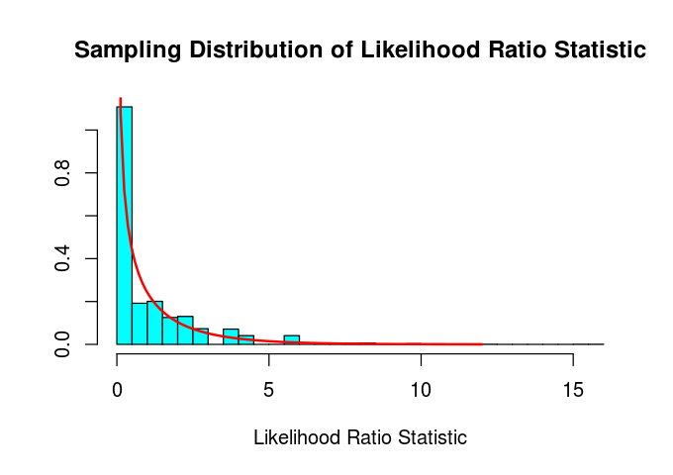

**For Binomial data the likelihood ratio statistic is a discrete or continuous random variable?**

**Continuous R.V.**

**How well does the Chi-squared(1) probability density function agree with the sampling distribution of the likelihood ratio statistic as approximated by the relative frequency histogram?**

**The Chi-square function approximates the sampling distribution of the likelihood ratio stat reasonably well**

**n = 100 theta = 0.319**

**The first 10 approximate 95% confidence intervals are:**

**[,1] [,2]**

**[1,] 0.1562917 0.3237083**

**[2,] 0.2471531 0.4328469**

**[3,] 0.2848643 0.4751357**

**[4,] 0.2565140 0.4434860**

**[5,] 0.2378383 0.4221617**

**[6,] 0.1475168 0.3124832**

**[7,] 0.3039800 0.4960200**

**[8,] 0.2565140 0.4434860**

**[9,] 0.2944010 0.4855990**

**[10,] 0.2753704 0.4646296**

**The proportion of approximate 95% confidence intervals which contain the true value of theta = 0.9448**

**How close is this proportion to 0.95? What are the reasons for this?**

Differs from 0.95 by about 0.5 %. Much closer than the 95% confidence intervals at n=30 because the sample size is much larger.

**The first ten 15% likelihood intervals (approximate 95% likelihood intervals) are:**

**[,1] [,2]**

**[1,] 0.1639623 0.3290341**

**[2,] 0.2525548 0.4354491**

**[3,] 0.2893233 0.4766818**

**[4,] 0.2616948 0.4458226**

**[5,] 0.2434669 0.4250081**

**[6,] 0.1554020 0.3180906**

**[7,] 0.3079566 0.4970481**

**[8,] 0.2616948 0.4458226**

**[9,] 0.2986188 0.4868835**

**[10,] 0.2800710 0.4664382**

**The proportion of 15% likelihood intervals which contain the true value of theta = 0.9448**

**How close is this proportion to 0.95? What are the reasons for this?**

**Like the 95% confidence intervals, this differs from 0.95 by about 0.5 %. This is similar to the proportion delivered by confidence intervals, since the advantage of using likelihood intervals decreases as the sample size grows.**

**Insert the plot of the sampling distribution of the likelihood ratio statistic for n=100 here.**

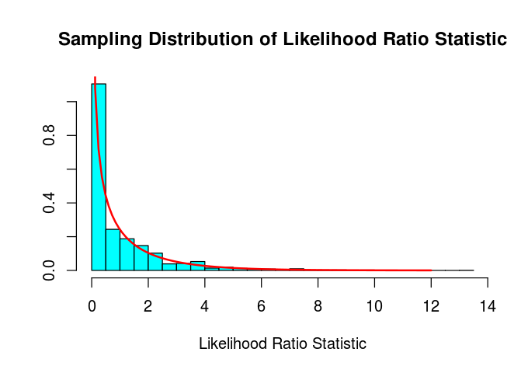

**How well does the Chi-squared(1) probability density function agree with the sampling distribution of the likelihood ratio statistic as approximated by the relative frequency histogram?**

**The fit of the chi-square to the likelihood ratio statistic is very good.**

**Compare the graphs for n=30 and n=100.**

**The fit of the chi-square to the likelihood ratio statistic is much better at n=100 than n=30, since the sample size is larger.**